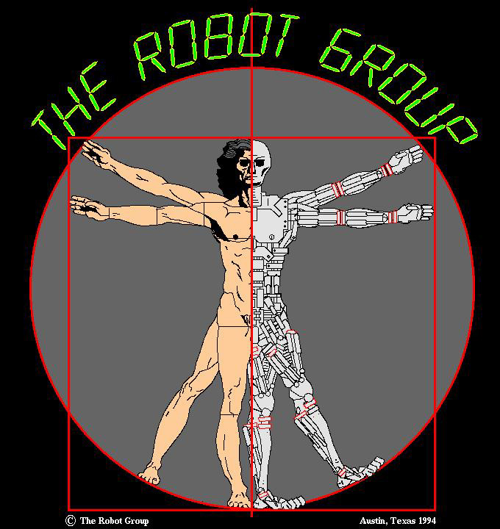
“The Black Knight”
By Eric Lundquist

The Black Knight started out as a "serious" mobile sensor platform. Built upon the reliable Robot Group chassis, the "head" originally held sensors such as video cameras and sonar sensors.

For the First Night Austin celebration, some decorations were added... and added... and added... The video camera eyes became Lighted High Intensity LED's. The hair came from old magnetic computer tapes. Shoulder pads and a dangerous looking gripper were added. Eventually, the project took on a life of its own.

The Black Knight is now exclusively a "Show Bot" that the Robot Group takes on many public appearances commanding attention wherever he goes.

