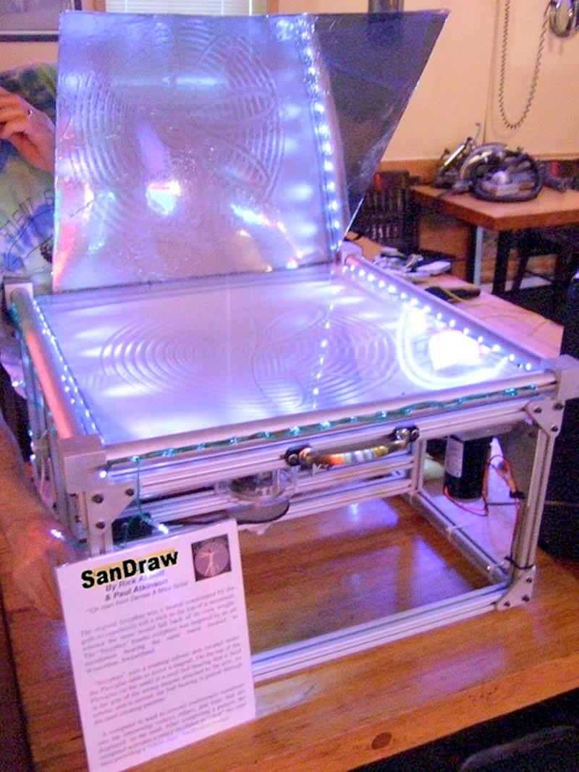
“SanDraw”
By Rick Abbott
& Paul Atkinson
**On loan from Denise & Mike Scioli

Inspired by Dr. Bruce Shapiro's original art piece "Sisyphus", SanDraw plots patterns in the sand using polar coordinates. SanDraw is made from hand-machined aluminum parts, Plexiglas, stepper motors and a microcontroller.

SanDraw uses a rotating robotic arm located under the Plexiglas table to move a magnet. On the top of the Plexiglas (in the sand) is a steel ball bearing that is held in the grip of the strong magnet attached to the arm. As robotic arm is moved, the ball bearing is pulled through the sand creating patterns.

A microprocessor is used to convert mathematic equations into the interesting valleys, ridges, and lines that are displayed in the sand. After completing a pattern, the computer activates a rotary oscillator to “clear” the sand thus providing a “clean slate” for it's next design.

